

Travlr Getaways

CS 465 Project Software Design Document
Version 3.0

Table of Contents

CS 465 Project Software Design Document 1
Table of Contents 2
Document Revision History 2
Instructions 2
Executive Summary 3
Design Constraints 3
System Architecture View 3
Component Diagram 3
Sequence Diagram 4
Class Diagram 4
API Endpoints 4
The User Interface 4

Document Revision History

Version | Date | Author | Comments
1.0 | 02/07/2025 | Laura Pittman | The first three sections were edited to contain accurate information regarding the Travlr software
2.0 | 02/15/2025 | Laura Pittman | The third and fourth sections were further edited to contain accurate information regarding the Travlr software architecture
3.0 | 02/25/2025 | Laura Pittman | The final section was edited to contain accurate information regarding the Travlr software user interface

Instructions

Fill in all bracketed information on page one (the cover page), in the Document Revision History table, and below each header. Under each header, remove the bracketed prompt and write your own paragraph response covering the indicated information.

Executive Summary

The purpose of the travel booking site is provide Travlr Getaways customers the ability to book travel packages, create an account, search for travel packages by location and price point, book reservations with our travel agency, and be able to visit the website regularly before their trip to see their itineraries. There will also be an admin-only site where Travlr Getaways administrators can maintain a customer base, available trip packages, and pricing for each item and package. This will be a full stack web application that uses the MEAN stack: MongoDB, Express, Angular, and Node.js. First, the architectural components will be mapped out and the development environment set up. Next, the customer-facing webpage will be customized to align with the wireframe provided and meet Travlr Getaways’ vision. This wireframe will be an initial reference to guide the construction of a static customer-facing website using HTML, CSS, and JavaScript. The next focus will be on the server side of the full stack application to set up the MongoDB database. From there the backend of the application will be coded using a NoSQL database that can store travel booking trips. The final steps will be to complete the client single-page application (SPA) using Angular, add the necessary security features, and do final testing on the full stack web application.

Design Constraints

There are various design constraints regarding the web-based Travlr Getaways application with the main two being the budget and the timeline as these two factors will greatly impact the development of the application. The budget may not allow for the cost of both the various licenses that might be needed as well as the development applications themselves. Additionally, the budget may not accommodate the number of team members that will be needed to complete the project by the agreed upon due date. Furthermore, the timeline may not allow for certain smaller features to be integrated into the final version of the application.

System Architecture View

Component Diagram

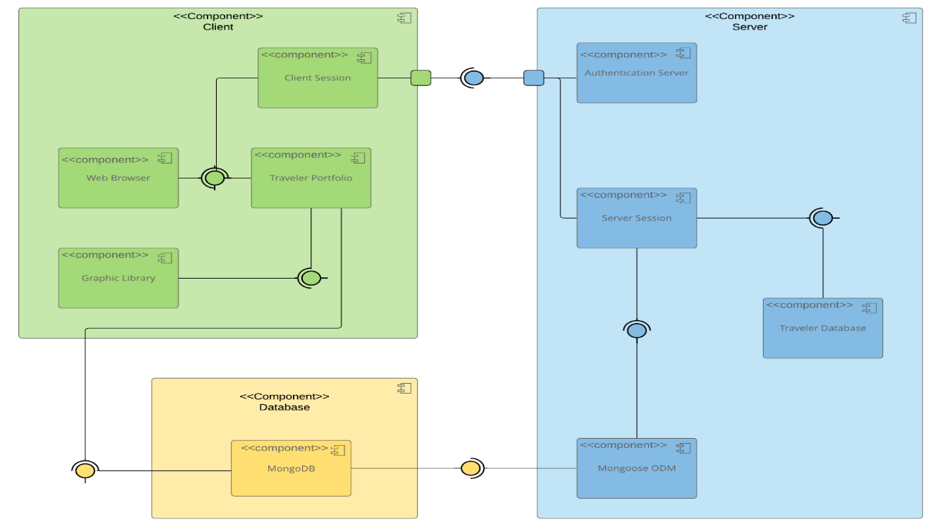

The diagram above represents the overall system architecture of the web application with the three major components: Server, Client, and Database. The purpose of the Client component is to hold the graphic library, traveler portfolio, web browser, and the client session to ensure the user experience is intuitive and seamless as the database is accessed by the traveler portfolio. The database will be a permanent spot for all data that will be accessed by both the Server and the Client through different methods. The purpose of the Server component is to hold the Mongoose ODM, traveler database, server session, and the authentication server to ensure secure access to the application and its elements.

Sequence Diagram

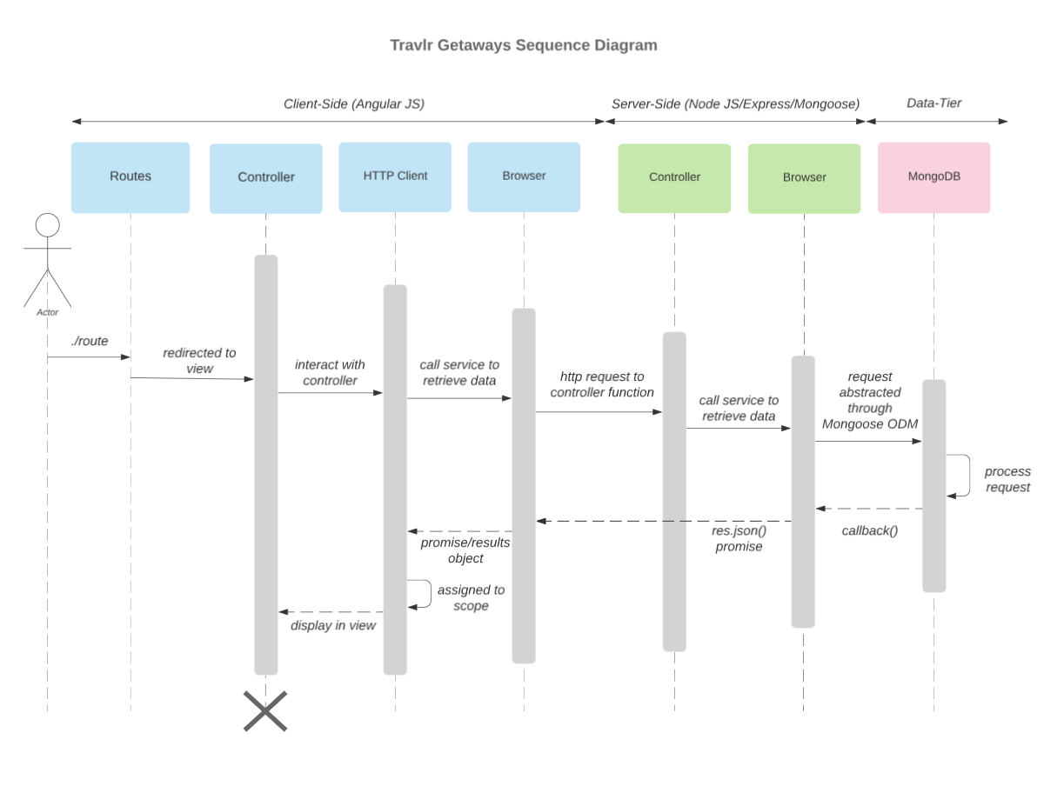

The sequence diagram above shows the client, server, and database components of the application and details the steps taken to access various parts of the application. First, the user logs in for the controller to interact with the HTTP client which will then call for data through the browser. The browser will then communicate with the server-side controller which then calls for data from the database. Then, the data is routed back through the browser on the server-side directly to the browser on the client-side. Finally, the client-side browser sends the data to the controller which then displays the results for the user to view.

Class Diagram
The class diagram above displays the various relationships between the multiple classes within the application. The TravellerInfo class holds the data for CruiseInfo, FlightInfo, and HotelInfo while the Itinerary holdes the data for HotelBooking, FlightBooking, and CruiseBooking. Additionally, TripInfo describes the data types of the components that make up the CruiseInfo, FlightInfo, and HotelInfo classes.

API Endpoints
Method | Purpose | URL | Notes
GET | <Retrieve list of things> | </api/things> | <Returns all active things>
GET | <Retrieve single thing> | </api/things/:thingId> | <Returns single thing instance, identified by the thing ID passed on the request URL>
POST | <Create new list of things> | </api/things> | <Creates a new list of active things>
POST | <Create single thing> | </api/things/:thingId> | <Creates a single thing instance, identified by the thing ID passed on the request URL>
PUT | <Updates list of things> | </api/things> | <Updates all active things>
PUT | <Updates single thing> | </api/things/:thingId> | <Updates single thing instance, identified by the thing ID passed on the request URL>
DELETE | <Deletes list of things> | </api/things> | <Deletes all active things>
DELETE | <Deletes single thing> | </api/things/:thingId> | <Deletes a single thing instance, identified by the thing ID passed on the request URL>

The User Interface

The Angular project structure is vastly different from that of the Express HTML customer-facing page with the main difference being the functionality that each piece provides to the application as the Express HTML is used for more of the backend side of the application while the Angular project structure is used for the front-end, user-facing part of the application. Additionally, the Angular project structure is primarily component based with each component having a separate folder whereas the Express HTML structure follows a server-side MVC pattern with separate HTML files that follow routes and controllers. Some advantages of the SPA functionality include the speed at which you are able to see the changes being made to the code meaning the website will reload as soon as you save the file you are working on, allowing you to see the changes right then as opposed to having to stop the server and then start it again and wait for it to reconnect, and the quick loading time for users due to it being run in the browser. The major disadvantage of SPA is the overall lack of security. The additional functionality provided by a SPA compared to that of a simple web application interaction is the ability to have seamless updates to page contents without the need for a full page reload. The process of testing to make sure the SPA is working with the API to GET and PUT data in the database starts with Postman to ensure the different variables of the trips are able to be viewed, added, and updated, and then moves to the application where confirmation can be made on whether or not the data is available and/or updated. I ran into a few errors when trying to test the update functionality as I was able to update the data within Postman and MongoDB Compass, but I was unable to update a trip from the application end. I was able to fix this error by re-doing that part of the project in a shorter timespan that ensured all new code was pushed to the running version of the application.

